GEOL 4237
Chapter 13
Floods

A different Kind of Killer Flood
- A poorly constructed steel tank holding 2.3 million gallons of molasses failed in January 1919 in Boston

- Temperature changed from 2 to 40 deg F on previous day

- Flood formed a 27 ft high wave traveling at 36 mi/hr.

- Killed 21 people and injured 150 people by suffocation & blunt force trauma

GEOL 4237
Chapter 13
Floods

How Rivers and Streams Work

- Profile for almost any stream is smooth, concave upward, with steeper slope near source

- Base level – level below which stream can not erode
(Place that stream flows into)
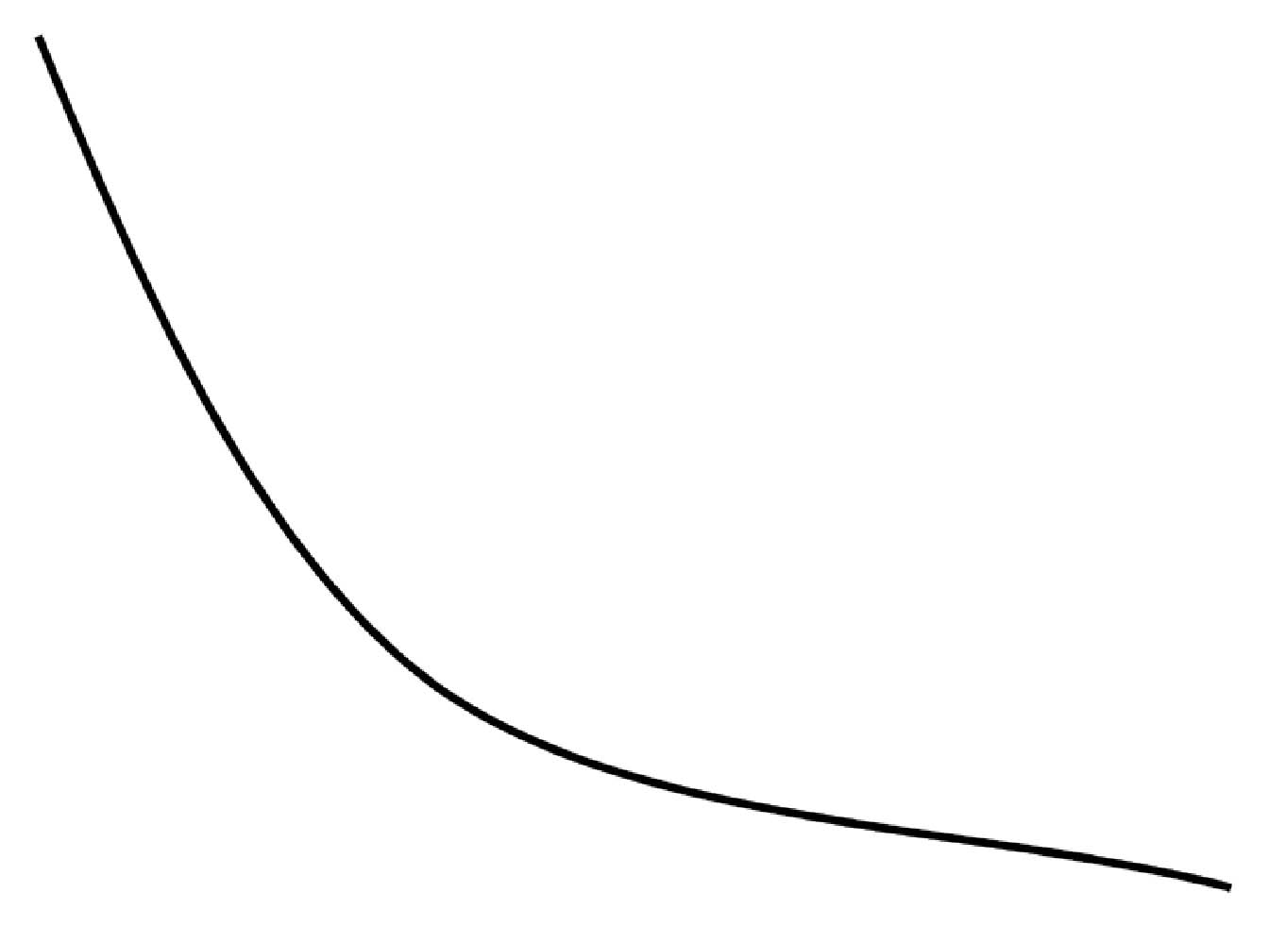
GEOL 4237
Chapter 13
Floods

- Streams act to seek equilibrium
- Factors:
- Discharge: rate of water flow, volume per unit of time

- Available sediment to be moved

- Gradient: slope of stream bottom

- Channel pattern: sinuosity of path

GEOL 4237
Chapter 13
Floods

Too Much Discharge - Case 1

Too much water → stream will flow more rapidly and energetically
Response:
- Excess energy erodes stream bottom and into banks

- Erosion of stream bottom results in less vertical drop → flatter gradient

- Erosion into stream banks creates meandering pattern → longer stream path, lower gradient
GEOL 4237
Chapter 13
Floods

Too Much Load-Case 2
Too much sediment → stream becomes choked
Response:

- Excess sediment builds up on stream bottom
- Buildup causes an increased gradient → water flows faster → can carry away more sediment
- Channel pattern becomes straighter
- Islands of sediment form within channel, creating braided stream pattern
- Similar to stream overflowing and eroding away landslide dam

GEOL 4237
Chapter 13
Floods

The floodplain

- Floors of streams during floods
- Built by erosion and deposition
- Floodplain was occupied during previous floods, and will be occupied again in future floods
- About 2.5% of U.S. land is floodplain – home to about 6.5% of population

GEOL 4237
Chapter 13
Floods
Flood Frequency

- Larger floods occur less frequently
- Analyze by plotting flood-discharge volumes vs. recurrence interval
- Can be used to estimate return time of given size flood
- 100-year flood used for regulatory requirements
- Flood-frequency curves are different for different streams

GEOL 4237
Chapter 13
Floods

Flood Styles

Several causes:
- Local thunderstorm or flash flood
- Rainfall over days → regional floods lasting weeks
- Storm surge of hurricane flooding coastal areas
- Broken ice on rivers can dam up → fail in ice-jam flood
- Short-lived failure of natural dams (landslide, log jam, lahar)
- Human-built levees or dams fail in flood

GEOL 4237
Chapter 13
Floods

Flash Floods
- Thunderstorms can release heavy rainfall, creating flash floods in steep topography
- Flash floods cause most flood-related deaths
- 50% of flood-related deaths are vehicle-related
Only two feet of moving water required to lift and carry away average car

Antelope Canyon, Arizona, 1997
- Narrow slot canyons of tributaries to Colorado River
- Thunderstorm releasing rain to form flash flood may occur too far away to hear or see
12 hikers killed by flash flood in 1997
GEOL 4237
Chapter 13
Floods

Big Thompson Canyon, Colorado, 1976
- Centennial celebrations brought thousands to canyon
- Stationary thunderstorm over area dumped 7.5 inches of rain in four hours
- Runoff created flash flood up to 6 m high, 25 km/hr
139 people killed, damage totaling $36 million

GEOL 4237
Chapter 13
Floods
Rapid Creek, Black Hills, South Dakota, 1972
- Pactola Dam built in 1952 to give flood protection and water supply to Rapid City, on Rapid Creek → increased development of floodplain
- Stationary thunderstorm poured up to 15 inches in 6 hours
- Canyon Lake overflowed as Canyon Lake dam broke, flooding Rapid City
- 238 people killed, $664 million in damages
- Floodplain remains undeveloped → greenbelt
- “No one should sleep on the floodway.”

GEOL 4237
Chapter 13
Floods

Regional Floods
High water for weeks
- Few deaths, extensive damage
Red River of the North: unusual northward flow (spring floods)
- Unusual northward flow – shallow valley
- As winter snow melts, flows northward into still frozen sections, causing floods
- Very low gradient-slow flowing water tends to pool

GEOL 4237
Chapter 13
Floods
Mississippi River System

- Greatest inundation floods in U.S.
- Third largest river basin in world
- System includes almost half of major rivers in U.S.
- Water flow can increase fourfold during flood

GEOL 4237
Chapter 13
Floods

Some Historic Floods
- New Orleans’ first large flood in year of founding, 1717
- Built levees to prevent future flood
- same response today
- Next flood when levees fail there is more flooding
- 1927 floods breached levees in 225 places, killed 183 people
- 1973 floods extended along 1,930 km of river, inundating 50,000 km²
- Aug 30, 2012 Hurricane Isaac breeched private levees
GEOL 4237
Chapter 13
Floods

The Great Midwestern Flood of 1993
- Biggest flood in 140 years – more than 20 million acres
- Wet winter
- Levees confined rivers and made water levels higher
- Levees damaged by waves, overtopping erosion
- 1,083 out of 1,576 levees fail
- Submerged 75 towns, caused $12 billion of damage

- Mississippi River wants to change course
- join shorter, steeper Atchafalaya River
- held in place by Army Corps of Engineers

China
- Attempts to control the Yellow River go back to 2356 B.C.E.
- In last 2,500 years, river has undergone ten major channel shifts
- moving location of mouth up to 1,100 km
- Sediment deposition builds up channel in elevation
- higher than surrounding floodplain
- Could lower elevation course in next flood
- Outside of old banks → avulsion
- 1887 avulsion sent the Huang River to join Yangtze River
- floods that resulted in over 1 million deaths
- Three gorges Dam now controls the Yangtze
- July 2012 flood was 69,000 cubic meters/second
- 1938 dynamiting of levees resulted in 1 million deaths
- Huang River today is 20 m higher than adjacent floodplain – kept in place by levees

GEOL 4237
Chapter 13
Floods

Societal Responses to Flood Hazards
- Structural responses:
- Dam construction
- Building levees
- Straightening, widening, deepening and clearing channel to increase water-carrying ability
- Sandbagging
- Nonstructural responses
- More accurate flood forecasting
- Zoning and land-use policies
- Insurance programs
- Evacuation planning
- Education

GEOL 4237
Chapter 13
Floods
Dams

- Dam construction gives sense of protection from floods, but dams do not control floods
- Life spans of dams are limited by construction materials, construction style, rate at which sediment fills reservoir
- Major floods occur downstream due to
- Overtopping
- Heavy rainfall below dam
- Dam failure
- 1981 study of dam safety by Army Corps of Engineers:
- 2,884 of 8,639 dams unsafe
- As of 2012, there are 13,991 dams that are high-hazard
Levees
- Levees may cost more than value of structures intended to protect
- Sense of security encourages further development of floodplain
- Upper Mississippi
- Peak floodwater heights increased 2 to 4 m (for same water volume) in last 150 years
- due to levees and engineered channels
- Stayed the same on unengineered upper Missouri River
- Floods in St. Louis crested at 11.6 m in 1903, 15.1 m in 1993 for same water volume

GEOL 4237
Chapter 13
Floods

Sandbagging
- Temporary levees of bags of sand and mud
- Estimated about 26.5 million sandbags used in 1993 floods
- Lessened damage in some places, but not in others
- Therapeutic value

Forecasting
- Forecasts of height and timing of regional floodwaters have significantly reduced loss of life
- Do not offset ever-greater damages, losses

GEOL 4237
Chapter 13
Floods

Zoning and Land Use
- National Flood Insurance Program, FEMA: ban building on floodplain covered by 100-year flood
- Discourages construction at frequently flooded sites but does not prevent all flooding of structures

GEOL 4237
Chapter 13
Floods

Insurance

- Flood insurance available from National Flood Insurance Program since 1950s
- rarely purchased outside of Hurricane threatened coastal areas
- Of 10,000 flooded households in Grand Forks, North Dakota in 1997, only 946 had flood insurance
- U.S. Congress comes to rescue – 1993 flood victims received $6.3 billion bill providing aid

GEOL 4237
Chapter 13
Floods

Hydrograph: plots volume of water (or stream depth) against time (Brays Bayou before and after urbanization)

- Urbanization changes shape of hydrograph, making curve much steeper
- Good news: urban flood might only last 20% as long
- Bad news: urban flood could be four times higher
GEOL 4237
Chapter 13
Floods

Flood Frequencies
- Urbanization increases surface runoff of rainwater → higher stream levels in shorter times (flash floods)

Channelization
- Try to control floodwaters by making channels clear of debris, deeper, wider and straighter
- Push stream into “too much discharge” case
- Stream response to regain equilibrium: erodes bottom and banks to pick up sediment and decrease gradient
- Extreme approach: Los Angeles – concrete lined channels
GEOL 4237
Chapter 13
Floods

Ice-Dam Failure Floods
- Biggest floods during melting of continental ice sheets → lakes behind ice dams that failed suddenly
- Most famous is the channeled scablands in Washington State.
- Evidence of flood from Lake Missoula after melting of ice dam:
- Lake sediments
- Land stripped of soil, sediment cover
- High-elevation flood gravels
- Integrated system of braided channels
- Abandoned waterfalls
- High-level erosion
- Large-scale sediment deposits

- Also the Great Lakes

